Smart Water System

**Project Definition:**

The project involves implementing IoT sensors to monitor water consumption in public places such as parks and gardens. The objective is to promote water conservation by making real-time water consumption data publicly available. This project includes defining objectives, designing the IoT sensor system, developing the data-sharing platform, and integrating them using IoT technology and Python.

**Design thinking:**

Objectives for a Smart Water System in IoT (Internet of Things) can include:

Water Conservation: Reduce water wastage through real-time monitoring and control of water usage, helping to conserve this valuable resource.

Leak Detection: Detect and alert users to leaks in the water supply system to prevent water loss and damage to infrastructure.

Water Quality Monitoring: Continuously monitor water quality parameters such as pH, turbidity, and contaminants to ensure safe and clean water supply.

Remote Control: Enable remote control of water systems for efficient management and response to changing conditions.

Predictive Maintenance: Implement predictive maintenance to identify and address issues in water infrastructure before they become major problems.

Data Analytics: Analyze data collected from sensors to gain insights into water consumption patterns and optimize water distribution.

Real-time Alerts: Provide real-time alerts to users or authorities in case of emergencies or unusual events, such as pipe bursts or contamination incidents.

Cost Reduction: Reduce operational costs by optimizing water distribution and reducing energy consumption in water treatment facilities.

Integration with IoT Ecosystem: Ensure interoperability with other IoT devices and systems for a holistic approach to smart city or smart home management.

Environmental Impact: Monitor and minimize the environmental.

**Sensor design:**

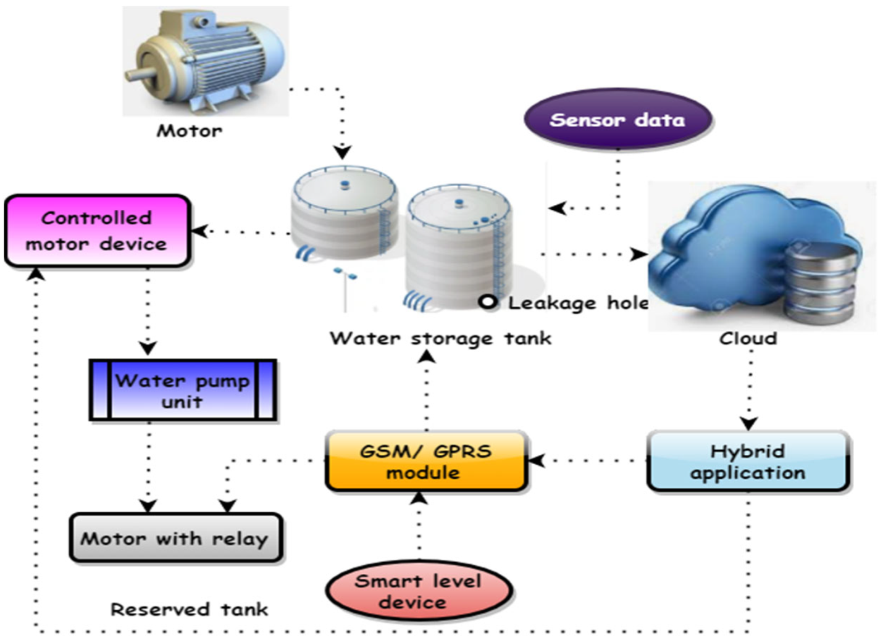

**Integration approaches:**

Integration approaches for a Smart Water System involve connecting various components, sensors, and technologies to create a cohesive and efficient system. Here are some integration approaches:

IoT Platform Integration: Utilize an IoT platform like AWS IoT, Google Cloud IoT, or Microsoft Azure IoT to manage and connect devices, collect data, and enable communication between sensors and the central system.

Sensor Integration: Incorporate a variety of sensors such as flow meters, pressure sensors, water quality sensors, and leak detectors to gather data about water infrastructure and quality.

Communication Protocols: Implement standard communication protocols like MQTT, CoAP, or HTTP to ensure data exchange between sensors, gateways, and the central control system is standardized and efficient.

Cloud Integration: Integrate with cloud services to store and analyze data, enabling scalability and accessibility from anywhere. Cloud platforms also provide tools for data processing and machine learning.

GIS (Geographic Information System) Integration: Incorporate GIS data for mapping and spatial analysis, which can help in identifying water infrastructure locations and optimizing distribution.

SCADA Systems: Integrate with Supervisory Control and Data Acquisition (SCADA) systems for real-time monitoring and control of water treatment and distribution processes.

Mobile and Web Applications: Develop user-friendly interfaces for consumers and authorities to access and control the system remotely via mobile apps or web platforms.

Machine Learning and AI Integration: Implement machine learning algorithms to analyze data for predictive maintenance, anomaly detection, and optimization of water distribution.

Legacy System Integration: In cases where older water infrastructure exists, integrate with legacy systems through gateways or protocol converters to modernize without replacing the entire infrastructure.

Security Integration: Implement robust cybersecurity measures to protect the system from cyber threats and unauthorized access, including encryption, authentication, and access control.

APIs and Webhooks: Provide APIs and webhooks to allow third-party applications and services to interact with the smart water system, fostering innovation and integration with other smart city components.

Data Analytics Tools: Integrate with data analytics tools and dashboards for visualizing and gaining insights from the collected data, which can aid in decision-making.

Emergency Services Integration: Establish connections with emergency services and local authorities to enable quick responses to water-related emergencies and incidents.

Data Standardization: Ensure data collected from various sensors and sources adhere to standardized formats and protocols for consistency and compatibility.

Energy Management Systems: If applicable, integrate with energy management systems to optimize energy usage in water treatment and distribution processes.